Keystone Testing Days & Bell Schedule
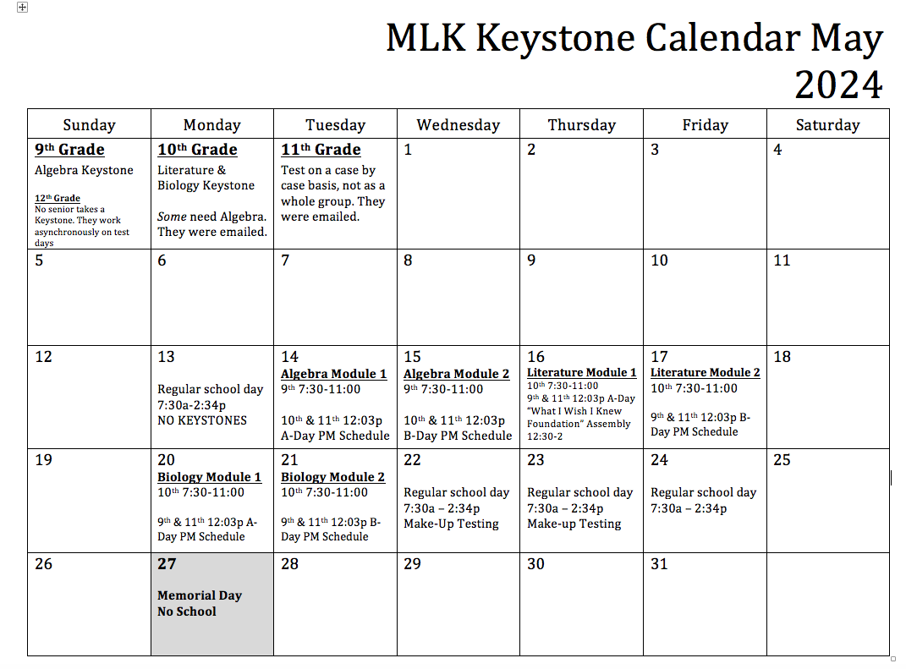

On test days…

7:30am - 8:05am - Advisory
- Tested students report to their 1st period class daily. They will test in their 1st period classrooms.
- 9th graders with 1st period gym report to 221 at 7:45am on Algebra test days
- List of 10th graders who need the ALGEBRA Keystone
- List of 11th graders who need Algebra, Literature, Biology

8:15am - 11:00am Testing
Students will test in their 1st period classrooms (with very few exceptions)
- 9th graders with 1st period gym report to 221 at 7:45am on Algebra test days
- 10th graders will report to the linked rooms on Literature & Biology test days
- Testing should begin thereabout 8:15 - Please collect electronics.
- Tested students can grab a “to go” lunch after testing as they dismiss by 11am
- Non-tested students will grab a “to go” lunch when they arrive for class at 12:03
- Seniors will complete asynchronous assignments that’ll count as attendance

Teacher Prep/Lunch 11am - 12noon

A Day Afternoons May 14th | May 16th | May 20th
1st Period - 12:03pm - 12:39pm (36 minutes)
2nd Period - 12:42pm - 1:18pm (36 minutes)
3rd Period - 1:21pm - 1:57pm (36 minutes)
4th Period - 2:00pm - 2:34pm (34 minutes) [←for 9th grade this is 5th period]

B Day Afternoons May 15th | May 17th | May 21st
6th Period - 12:03pm - 12:39pm (36 minutes) [←for 11th grade this is 5th period]
7th Period - 12:42pm - 1:18pm (36 minutes)
8th Period - 1:21pm - 1:57pm (36 minutes)
9th Period - 2:00pm - 2:34pm (34 minutes)

Breakfast and lunch times will remain the same

